**Statistical Model Integration Project**

**Project Summary:**

Looking for Integration of Statistical Model written in Python code in gateway device. Requires code debugging and changing the input parameters in the code to get the desired output.

**Deliverables:**

**Step 1: Statistical Model (Python Code)**

* Validate db schema (Database A).
* Debug the old code.
* Change the input parameters from excel / csv files into database table.
  + 240 sensor values from _ **16_hs_clean_pipeline** table in Database A
  + 16 sensor values from **_ref valu_16** table in Database A
* Get the desired outputs:
  + to db-c - timestamp, % change
  + In local filesystem - csv - timestamp, % change, parameters of model
* Use timestamp of data cycle (not the timestamp when code was run)
* Read from Database-A on the gateway and output to Database-C “cur_app_clinical_events” table on the Linux Server.
* Model should only output flags - 0 or 1 for each cycle into the “cur_app_clinical_events” table. (0 = no event ; 1 = moisture event)

**Input data format**

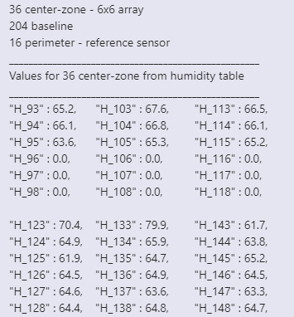

**Statistical Model – New Code flow**



**Requirements:**

* **Push the code on Github and email.**
* **https://github.com/amooman**